Week6_Creating a Multi-Component React App (StudentApp)

Objective:

Create a react app for Student Management Portal named StudentApp and create a component named Home which will display the Message “Welcome to the Home page of Student Management Portal”. Create another component named About and display the Message “Welcome to the About page of the Student Management Portal”. Create a third component named Contact and display the Message “Welcome to the Contact page of the Student Management Portal”. Call all the three components.

Phase 1: Setting Up Your Development Environment
Step 1: Install Node.js and npm
- Explanation: Node.js is a JavaScript runtime that lets you run JavaScript on your computer. npm is the package manager for Node.js, used to install and manage project dependencies like React.
- Action:
- Open a web browser and navigate to the official Node.js download page: https://nodejs.org/en/download/
Step 2: Install Visual Studio Code
- Explanation: Visual Studio Code (VS Code) is a free, powerful code editor that is highly recommended for React development.
- Action:
- Go to the official VS Code website: https://code.visualstudio.com/
- Download and run the installer for your operating system.
Step 3: Install create-react-app
- Open your command prompt (on Windows) or terminal (on macOS or Linux).
- Type the following command:
npm install -g create-react-app
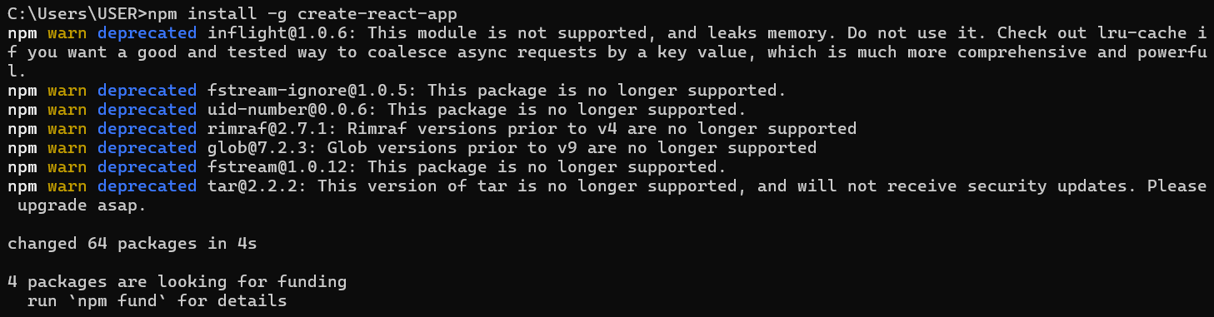

Phase 2: Creating and Running the React Application
Step 4: Create the React Application
- In your command prompt or terminal, navigate to the directory where you want to store your project (e.g., your Desktop or a development folder).
- Type the following command and press Enter. This may take a few minutes to complete.
create-react-app studentapp

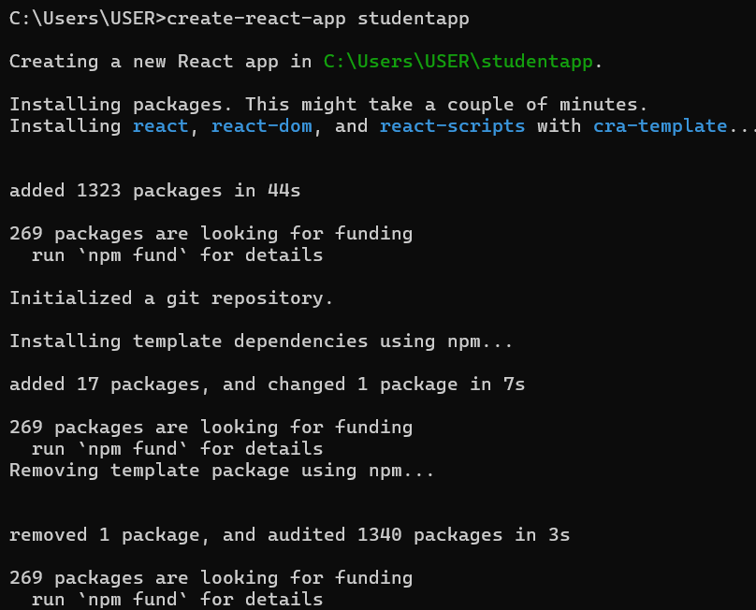
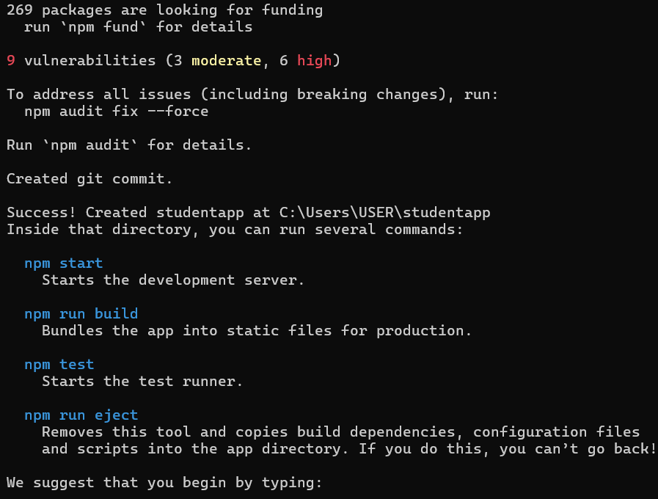

Step 5: Navigate into Your New Project Folder
- You must be inside the project folder to run commands related to this specific application.
- Once the command from Step 4 is finished, type the following command to move into the newly created directory:
cd studentapp
Step 6: Open the Project in Visual Studio Code
- This command opens the entire project folder in VS Code, allowing you to easily browse and edit the project files.
- While in the myfirstreact folder in your command prompt or terminal,
- Type the command:
code .
Note: The . tells VS Code to open the current directory.
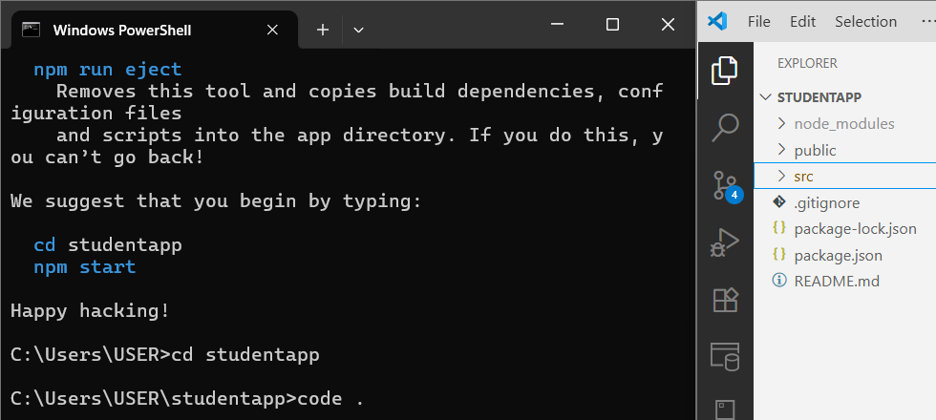
Step 7: Create the Components Folder
- In VS Code's explorer, right-click the src folder.
- Select "New Folder" and name it Components.
Step 8: Create the Home.js Component
- Right-click the new Components folder and select "New File".
- Name the file Home.js and add the following code:
import React, { Component } from 'react';
class Home extends Component {
render() {
return (
<div><h1>Welcome to the Home page of Student Management Portal</h1></div>
);
}
}
export default Home;
Step 9: Create the About.js Component
- Right-click the Components folder and select "New File".
- Name the file About.js and add the following code:
import React, { Component } from 'react';
class About extends Component {
render() {
return (
<div><h2>Welcome to the About page of the Student Management Portal</h2></div>
);
}
}
export default About;
Step 10: Create the Contact.js Component
- Right-click the Components folder and select "New File".
- Name the file Contact.js and add the following code:
import React, { Component } from 'react';
class Contact extends Component {
render() {
return (
<div><p>Welcome to the Contact page of the Student Management Portal</p></div>
);
}
}
export default Contact;
Step 11: Edit App.js to Display the Components
- Open the App.js file located in the src folder.
- Replace all of its content with the following code:
import React from 'react';
import './App.css';
import Home from './Components/Home';
import About from './Components/About';
import Contact from './Components/Contact';
function App() {
return (
<div className="App">
<Home />
<About />
<Contact />
</div>
);
}
export default App;
Step 12: Run the Application
- Go back to your terminal (it should still be in the StudentApp folder).
- Run the start command:
npm start

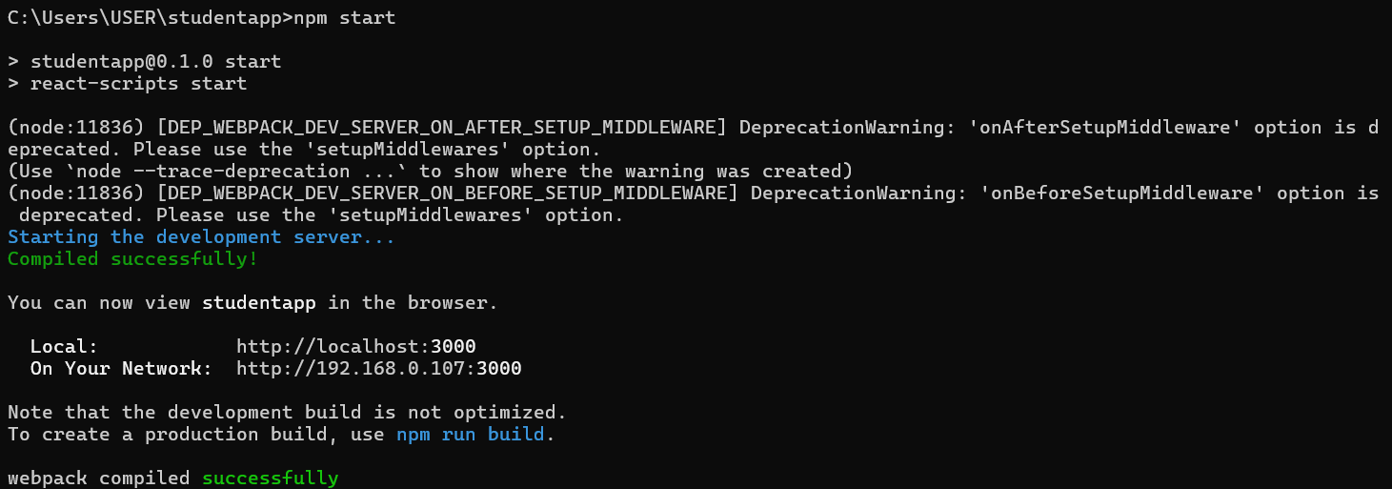

Step 13: View Your Application
- The development server hosts your application on a local port, typically 3000.
Local: http://localhost:3000
On Your Network: http://192.168.0.107:3000

Output:

